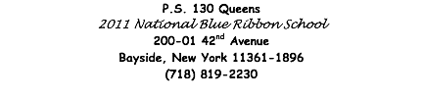

February 2, 2021

Dear P.S. 130 Families,

Each student and staff member brings to our school community the richness of our city’s cultural diversity and the desire for respect. We are committed to promoting respect for diversity among students and between students and staff so that all of our students feel valued, safe, and supported.

It is the policy of the New York City Department of Education (DOE) to maintain a safe and supportive learning and educational environment that is free from harassment, intimidation and/or bullying, sexual harassment, and discrimination on account of actual or perceived race, color, age, creed, ethnicity, national origin, citizenship/immigration status, religion, gender, gender identity, gender expression, sexual orientation, disability, or weight.

Respect for All Week will take place from February 5, 2021, through February 11, 2021. As a school community, we are going to have fun themed days planned for the week. “Respect for All” teaches our students how to accept differences, celebrate individuality, prevent-bullying, and teach about kindness, encouragement, and friendships.

Please see the themes below and support your children's participation.

Sincerely,
Ereni Polydefkis
School Counselor

Friday (2/5) | No One Eats Alone Day (Students will eat lunch with their peers and teachers and participate in fun activities)
Monday (2/8) | Wearing Positive and Encouraging Words Day
Tuesday (2/9) | Wear Something That Represents Your Personality or Culture
Wednesday (2/10) | Kindness Day (Students set out goals to do or say kind things throughout the school day)
Thursday (2/11) | Put a lid on Racism Day! Students wear silly hats!

