P.S. 130 Queens
2011 National Blue Ribbon School
Catherine Specchia Loreli Aguiar
Principal Assistant Principal
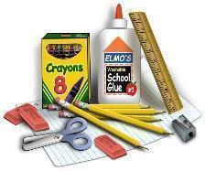
Third Grade Supply List 2023-2024

Welcome to third grade! We are excited to be teaching your child and look forward to a productive and rewarding year ahead! Below is a list of supplies that will be needed in school and at home. Notebooks and folders should be labeled with your child’s name and the subject area. Thank you in advance for your cooperation and support for a successful school year!

You may send in individual sanitizers/hand wipes for your own child to keep at his/her desk. We also encourage each child to bring in his/her own water bottle daily.

Please purchase the following items that your child will need:
- FIVE hardcover marble composition notebooks, labeled with name and subject
    - Reading/Writing Notebook
    - Math /Social Studies Notebook
    - SEL Notebook (311 ONLY)
    - Science Notebook
    - Homework

- THREE PLASTIC folders with 2 bottom pockets and
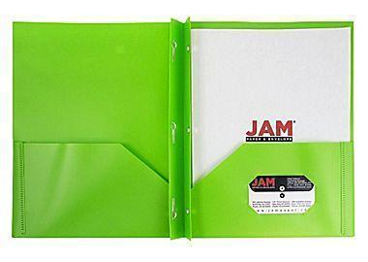
3 fasteners (See picture), labeled with name and subject.

*PLEASE ADD 10 CLEAR PLASTIC SHEET
PROTECTORS TO EACH FOLDER.

    - Math – blue →
    - Writing - orange
    - Social Studies – red

- FOUR plastic folders with 2 bottom pockets, labeled
with name and subject
    - Test prep – purple
    - Reading – white
    - Science - green
    - Homework – any design

- Two soft, LARGE zippered pencil cases (to be filled - see table below) no hard cases please
- One box of blue pens
- Two boxes black pens
- One pencil sharpener (with a cover) (labeled)
- 24-48 sharpened Ticonderoga™ pencils
- 24-48 sharpened Ticonderoga™ pencils (to be kept at home)
- One pair of Fiskars™ scissors (labeled)
- Crayons (no more than 24 count)
- One box of Crayola™ THIN markers (no more than 10 count)
- One bottle of Elmer’s™ liquid glue (4oz)
- SIX Elmer’s™ glue sticks (small)
- Post-it™ notes: 4 packages of 3”x3” and 2 lines packages of 3”x5”
- Five thin EXPO™ dry erase markers (any color)
- One black thin FINE TIP or TWIN TIP (fine/ultra fine) SHARPIE™ permanent marker (labeled)

To start the year off in an organized way we would like students to fill their pencil cases, prior to the first day of school, with the following items in each pencil case. The remaining items will be collected, and stored in the classroom for future replenishment.

Pencil Case #1 | Pencil Case #2
2 pencils  2 blue pens  2 black pens  pencil sharpener  1 pack of each size post-its  2 thin EXPO™ markers  1 fine SHARPIE™ | scissors  1 glue stick  1 bottle Elmer’s liquid glue  Thin markers  Crayons

Please send in on the 2nd day of school.
- One box of tissues
- Two packages Baby wipes OR Wet Ones™
- $7 in an envelope labeled for “Scholastic News” (write your child’s name on the envelope)
- One box of large Ziploc™ bags (gallon size) (boys only)
- One box of small Ziploc™ bags (sandwich size) (girls only)
- One roll of paper towels (individually wrapped - NOT loose)
- Personal headphones for laptop use (labeled in a small Ziploc™ bag or case)
- A healthy snack each day.
*If your child has food allergies, please send in a box of treats (labeled with name) that your child can eat/drink during celebrations.

LOOKING FORWARD TO SEEING YOU IN SEPTEMBER!!!

